Výukový materiál zpracovaný v rámci projektu

Registrační číslo projektu: CZ.1.07/1.4.00/21.1174
Škola – adresa: Základní škola, Dobrá, okres Frýdek-Místek www.zsdobra.cz, zsdobra@zsdobra.cz
Šablona: č. III/2 Aj7

Ověření ve výuce (dne): 21. 3. 2013 Pořadové číslo hodiny: 16.
Třída: 9. B Předmět: Anglický jazyk

Název: | Texty v učebnici a učebních materiálech
Anotace: | Pracovní list slouží k práci s textem a upevňování čtenářských dovedností (porozumění textu). Žáci si čtou krátkou povídku, seznamují se s novou slovní zásobou a několika způsoby demonstrují porozumění textu (dokončení komiksu, ověřování pravdivosti tvrzení, odpovědi na otázky). Závěrem ve skupinách text dramatizují a hrají.
Autor: | Mgr. Jan Lörinc
Jazyk: | čeština, angličtina
Očekávaný výstup: | Čte nahlas plynule a foneticky správně texty přiměřeného rozsahu.
Speciální vzdělávací potřeby: | žádné
Klíčová slova: | práce s textem, slovní zásoba, porozumění textu, pravdivost tvrzení, komiks, otázky a odpovědi, dramatizace textu
Rozvíjené klíčové kompetence: | kompetence k učení, kompetence komunikativní, kompetence sociální a personální, kompetence k řešení problémů, kompetence pracovní
Druh učebního materiálu: | pracovní list
Druh interaktivity: | aktivita
Cílová skupina: | žák
Stupeň a typ vzdělávání: | základní vzdělávání – druhý stupeň
Ročník: | devátý
Celková velikost: | 125 kB
Vazby na ostatní materiály:  (Seznam dokumentace) | -

a short horror story by Jan Lörinc

There was an ugly-looking sculptor who lived in a big lonely house somewhere in the mountains of Wales. He was quite rich but so ugly that he couldn’t find any love however hard he tried. One day he decided to solve his problem and started to sculpt a statue of a beautiful young woman. Of course he wasn’t that naive as to think that she’ll come to life just like that. No, no, but he resorted to dark arts of forbidden magic and planned to use powerful spells during the creation of his new statue. It was his last hope.
While he was making the statue, he cast a lot of terrible spells and every day the statue looked more and more like a real living woman. But then some masked robbers broke into his house at night. They had heard about his riches and wanted to steal all his money. But the sculptor wasn’t sleeping, he was working on his statue that was almost finished. The robbers attacked him and hit him on the head with a club. His blood splattered on the statue and he died. After that the robbers burnt his body in order to cover up their murder and started looking for hidden money.
But then the most incredible thing happened. The statue splattered with sculptor’s blood came into life. She opened her eyes and took a breath. She was very beautiful. When she saw her maker’s lifeless body, she cried out and her eyes filled with tears. She didn’t wait a second more and in her rage she ripped the robbers apart with inhuman strength. They screamed in horror and fear but she didn’t spare a single one.
The statue killed all the robbers and used their blood and bones to recreate her creator and master. She read all his books about black magic and cast the most horrible spells on the monstrous body she had sewn together with the robber’s body parts and transferred sculptor’s soul into it. The hideous form came to life and both beings embraced for the first time. Their love was strong, but they made a very unlikely pair. An angelic beauty of the statue contrasted with the grizzly appearance of the zombie sculptor. To this day they live in this big lonely house deep in the Welsh mountains. If you ever come to this part of Wales, pay them a visit. They will tear your body to pieces and eat it. Consider yourself warned.

Interesting Vocabulary
Use your dictionary and fill in the chart.

English | Pronunctiation | Czech
a sculptor
to resort
forbidden
cast
a robber
to splatter
to rip apart
to sew
to embrace

Comic Strip – A Marble Revenge
Write the appropriate passage from the text into the blank spaces. Draw and write the rest of the story into the two remaining panels. You can use speech bubbles if you want.

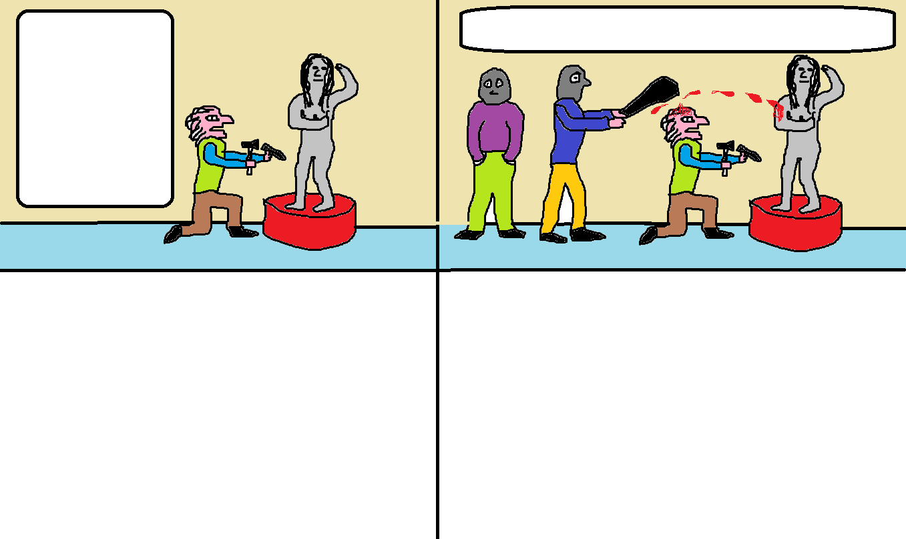

Text Comprehension Exercises

- True or False? Are the statements true or false?

- The sculptor lived in a city. _________
- He didn’t look for a woman. _________
- His last statue was very special. _________
- He used black magic. _________
- Robbers buried sculptor’s body. _________
- They ran away after seeing the living statue. _________

- Answer the questions.

Why did the sculptor make a statue of a woman?
How did he want to revive the statue?
What did robbers do with sculptor’s body?
How the statue come to life?
How did she revive her master?
What material was the statue made of?

- Work in group of 3 or 4 students. Rewrite the short story into a dramatic sketch and act it out.

Řešení:
- a) false, b) false, c) true, d) true, e) false, f) false

- Possible answers:

Because he couldn’t find love.
He used black magic.
They burnt his body.
Sculptor’s blood splattered on the statue.
She sewed robbers’ body parts together and cast a spell.
She was made of marble.

Citace:

