Výukový materiál zpracovaný v rámci projektu

Registrační číslo projektu: CZ.1.07/1.4.00/21.1174
Škola – adresa: Základní škola, Dobrá, okres Frýdek-Místek www.zsdobra.cz, zsdobra@zsdobra.cz
Šablona: č. III/2 Aj7

Ověření ve výuce (dne): 25. 2. 2013 Pořadové číslo hodiny: 10.
Třída: 9. B Předmět: Anglický jazyk

Název: | Nancy Sinatra – Bang Bang (pracovní list k písni)
Anotace: | Žáci poslouchají píseň a doplňují chybějící slova do textu. Zároveň si čtou krátký text o slavné osobnosti. Dále se zaměřují na tvary nepravidelných sloves. V druhé části se věnují porozumění textu, kdy odpovídají na otázky a převádějí text písně do příběhu.
Autor: | Mgr. Jan Lörinc
Jazyk: | čeština, angličtina
Očekávaný výstup: | Stručně reprodukuje obsah přiměřeně obtížného textu, promluvy a konverzace
Speciální vzdělávací potřeby: | žádné
Klíčová slova: | text písně, poslech, Nancy Sinatra, minulý čas prostý, nepravidelná slovesa, porozumění textu, otázky a odpovědi, tvorba textu
Rozvíjené klíčové kompetence: | kompetence komunikativní, kompetence k řešení problémů, kompetence k učení, kompetence pracovní
Druh učebního materiálu: | pracovní list
Druh interaktivity: | aktivita
Cílová skupina: | žák
Stupeň a typ vzdělávání: | základní vzdělávání – druhý stupeň
Ročník: | devátý
Celková velikost: | 401 kB
Vazby na ostatní materiály:  (Seznam dokumentace) | -

- Listen to the song and fill in the missing words.

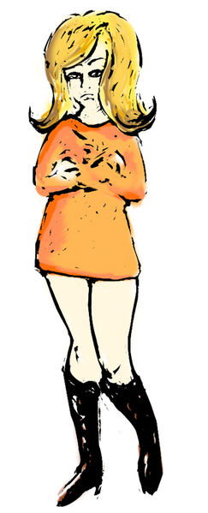
I was five and he was _________
We rode on horses _________ of sticks
He wore black and I wore white
He would ___________ win the fight

Bang bang, he ___________ me down
Bang bang, I hit the ground
Bang bang, that awful sound
Bang bang, my baby ___________ me down.

Seasons came and changed the __________
When I grew up, I ___________ him mine
He would always laugh and say
"___________ when we used to play?"

Bang bang, I __________ you down
Bang bang, you hit the ground
Bang bang, that awful sound
Bang bang, I used to ___________ you down.

Music ___________, and people sang
Just for me, the church bells rang.

Now he's gone, I don't __________ why
And till this day, ___________ I cry
He didn't even say goodbye
He didn't ___________ the time to lie.

Bang bang, he ___________ me down
Bang bang, I hit the ground
Bang bang, that awful sound
Bang bang, my baby ____________ me down...

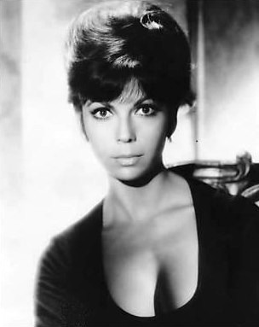 | Interesting Facts  Nancy Sinatra (born 1940) is an American singer and actress.  She is the daughter of a famous singer and actor Frank Sinatra.  Her best known hit is „These Boots Are Made for Walkin’”.  A Czech singer Yvonne Přenosilová made a cover of it called „Boty proti lásce“.

- Irregular verbs. Find all irregular verbs in the lyrics and fill in the chart.

Czech | Infinitive | Past Simple | Past Participle

- Answer the questions about the lyrics.

When did the story begin?
What game did they play as children?
What happened when they grew up?
What does the line „the church bells rang“ mean?
Did he really shoot her down at the end of their story? If not, why does she says so?

- Retell the girl’s story. Use at least 5 sentences.



Řešení
- Doplněný text

I was five and he was six
We rode on horses made of sticks
He wore black and I wore white
He would always win the fight

Bang bang, he shot me down
Bang bang, I hit the ground
Bang bang, that awful sound
Bang bang, my baby shot me down.

Seasons came and changed the time
When I grew up, I called him mine
He would always laugh and say
"Remember when we used to play?"

Bang bang, I shot you down
Bang bang, you hit the ground
Bang bang, that awful sound
Bang bang, I used to shoot you down.

Music played, and people sang
Just for me, the church bells rang.

Now he's gone, I don't know why
And till this day, sometimes I cry
He didn't even say goodbye
He didn't take the time to lie.

Bang bang, he shot me down
Bang bang, I hit the ground
Bang bang, that awful sound
Bang bang, my baby shot me down...

- Irregular Verbs

Czech | Infinitive | Past Simple | Past Participle
být | be | was/were | been
jezdit | ride | rode | ridden
udělat | make | made | made
nosit (oblečení) | wear | wore | worn
vyhrát | win | won | won
střelit | shoot | shot | shot
udeřit | hit | hit | hit
přijít | come | came | come
vyrůst | grow up | grew up | grown up
říci | say | said | said
zpívat | sing | sang | sung
zvonit | ring | rang | rung
jít | go | went | gone
vědět | know | knew | known
vzít | take | took | taken

Pozor: „lie“ (lhát) je pravidelné, nepravidelné je „lie“ (ležet).

- Příklady odpovědí

It began in their childhood (when they were children).
They played some role-playing game, e. g. cowboys and indians, or police and thieves.
They fell in love with each other.
It means they got married.
He didn’t really shot her, but she says so because she felt terribly betrayed or dead.

Citace:

Obr. 1: File:Nancy_Sinatra_jnl.jpg. In Wikipedia : the free encyclopedia [online]. St. Petersburg (Florida) : Wikipedia Foundation, [cit. 2012-04-15]. Dostupné z WWW: http://commons.wikimedia.org/wiki/File:Nancy_Sinatra_jnl.jpg. Dostupné pod licencí CreativeCommonsAttribution-ShareAlike3.0 na WWW: http://commons.wikimedia.org/wiki/File:Nancy_Sinatra_jnl.jpg.

Obr. 2: File:Nancy_Sinatra.JPG. In Wikipedia : the free encyclopedia [online]. St. Petersburg (Florida) : Wikipedia Foundation, [cit. 2012-04-15]. Dostupné z WWW: http://en.wikipedia.org/wiki/File:Nancy_Sinatra.JPG. Dostupné pod licencí CreativeCommonsAttribution-ShareAlike3.0 na WWW: http://en.wikipedia.org/wiki/File:Nancy_Sinatra.JPG.

Použitý obrázek je dostupný pod licencí Microsoft Office 2010 na Office.com.

http://officeimg.vo.msecnd.net/en-us/images/MH900334376.jpg

